Market trend and overview

The Advanced Air Mobility (AAM) market offers a solution to millions of passengers by addressing several challenges of urban and rural mobility, typically covering distances under 100 kilometers.
AAM represents the burgeoning transportation industry that encompasses the development of related infrastructure such as vertiports, charging stations, and air traffic management systems. These elements are crucial for integrating new modes of transportation into the existing aviation landscape.
By 2030, leading companies in the passenger AAM sector could surpass the world’s largest airlines in terms of fleet size and the number of daily flights offered. These flights are expected to be shorter, with an average duration of 18 minutes, and will accommodate fewer passengers (between one and six, plus a pilot).
The market features three main vehicle configurations: multi-rotor, compound, and tiltrotor. In line with this, EASA regulations reference FAA AC 23.1309-1E in the ASTM standards for failure, requiring vehicles to meet the standards for continuous safe flight and landing. They must also be capable of reaching the original intended destination or a suitable alternate vertiport following a failure. Among these configurations, the tiltrotor (wing) is deemed most suitable for meeting reliability and capacity safety requirements, thus complying with the upper limit for the average probability of failure per flight hour. A report from NASA indicates that the reliability rate for loss of function in urban flights should exceed 10^-6 for complex systems, including those with electric components. Consequently, leading competitors are focusing on configurations with more than six rotors and aerodynamic surfaces such as wings (tiltrotor) to surpass this requirement.
Small cities, communities, and other destinations stand to benefit significantly from the low investment required to establish a vertiport compared to other transportation methods. This accessibility, facilitated by AAM technologies, is expected to spur growth in these areas, leading to an increase in destinations and sources of income.
A conventional takeoff and landing (eCTOL) capability will provide a significant advantage over numerous competitors due to its extended range and the influx of investment into this configuration.
The United States boasts over 14,000 airports, including 102 international ones, while Europe has more than 500. This extensive network, combined with a longer range of up to 200 kilometers, is expected to open a market worth over 30 billion by 2030.
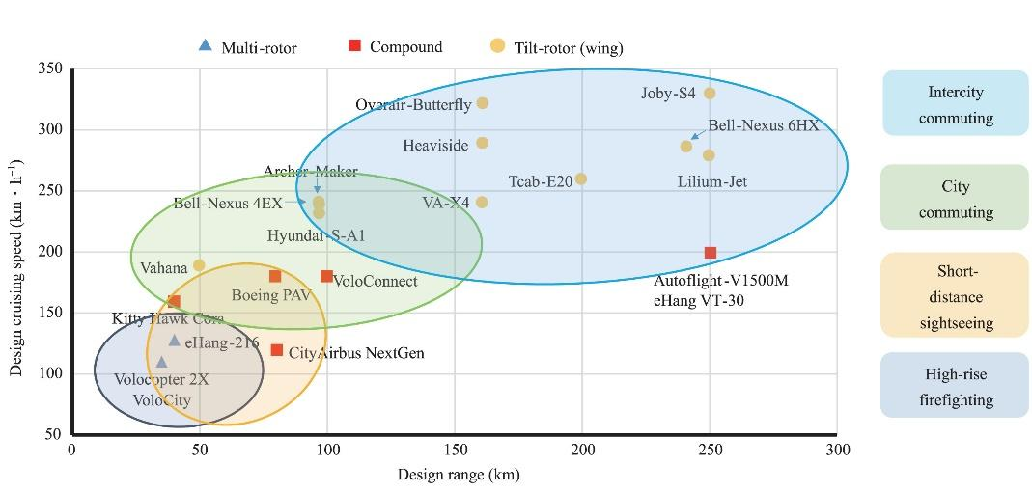
Figure 1 range and cruising speed/ lift classification and operative scenarios

Article title: Advanced Air Mobility Market Update - Vertical Flight Society https://www.asianskygroup.com/advanced-air-mobility-market-update-vertical-flight-society-123/ Website title: Asian Sky Group, Date accessed March 14, 2024, Date published February 27, 2024.
Article title: The Next Normal – The future of air mobility: Electric aircraft and flying taxis, https://www.mckinsey.com/featured-insights/the-next-normal/air-taxis , Website title McKinsey & Company Date accessed March 14, 2024
No: SC-VTOL-01 for special condition Vertical Take-Off and Landing (VTOL)
Article Title: Hazards Analysis and Failure Modes and Effects Criticality Analysis (FMECA) of Four Concept Vehicle Propulsion Systems - NASA Technical Reports Server (NTRS), https://ntrs.nasa.gov/citations/20190026443, Website title: NASA, Date accessed: March 14, 2024
Article title: Advanced Air Mobility Market Update - Vertical Flight Society, https://www.asianskygroup.com/advanced-air-mobility-market-update-vertical-flight-society-123/ , Website title: Asian Sky Group, Date accessed: March 14, 2024, Date published: February 27, 2024
Article title: eVTOL Market Size to Reach USD 30,519 Million by 2030, https://www.acumenresearchandconsulting.com/press-releases/evtol-market, Website title: Acumen Research and Consulting, Date accessed: March 14, 2024
Article title: Autonomous eVTOL: A summary of researches and challenges, https://www.sciencedirect.com/science/article/pii/S2773153723000762 Website title: Green Energy and Intelligent Transportation, Date accessed: March 14, 2024, Date published: November 25, 2023

